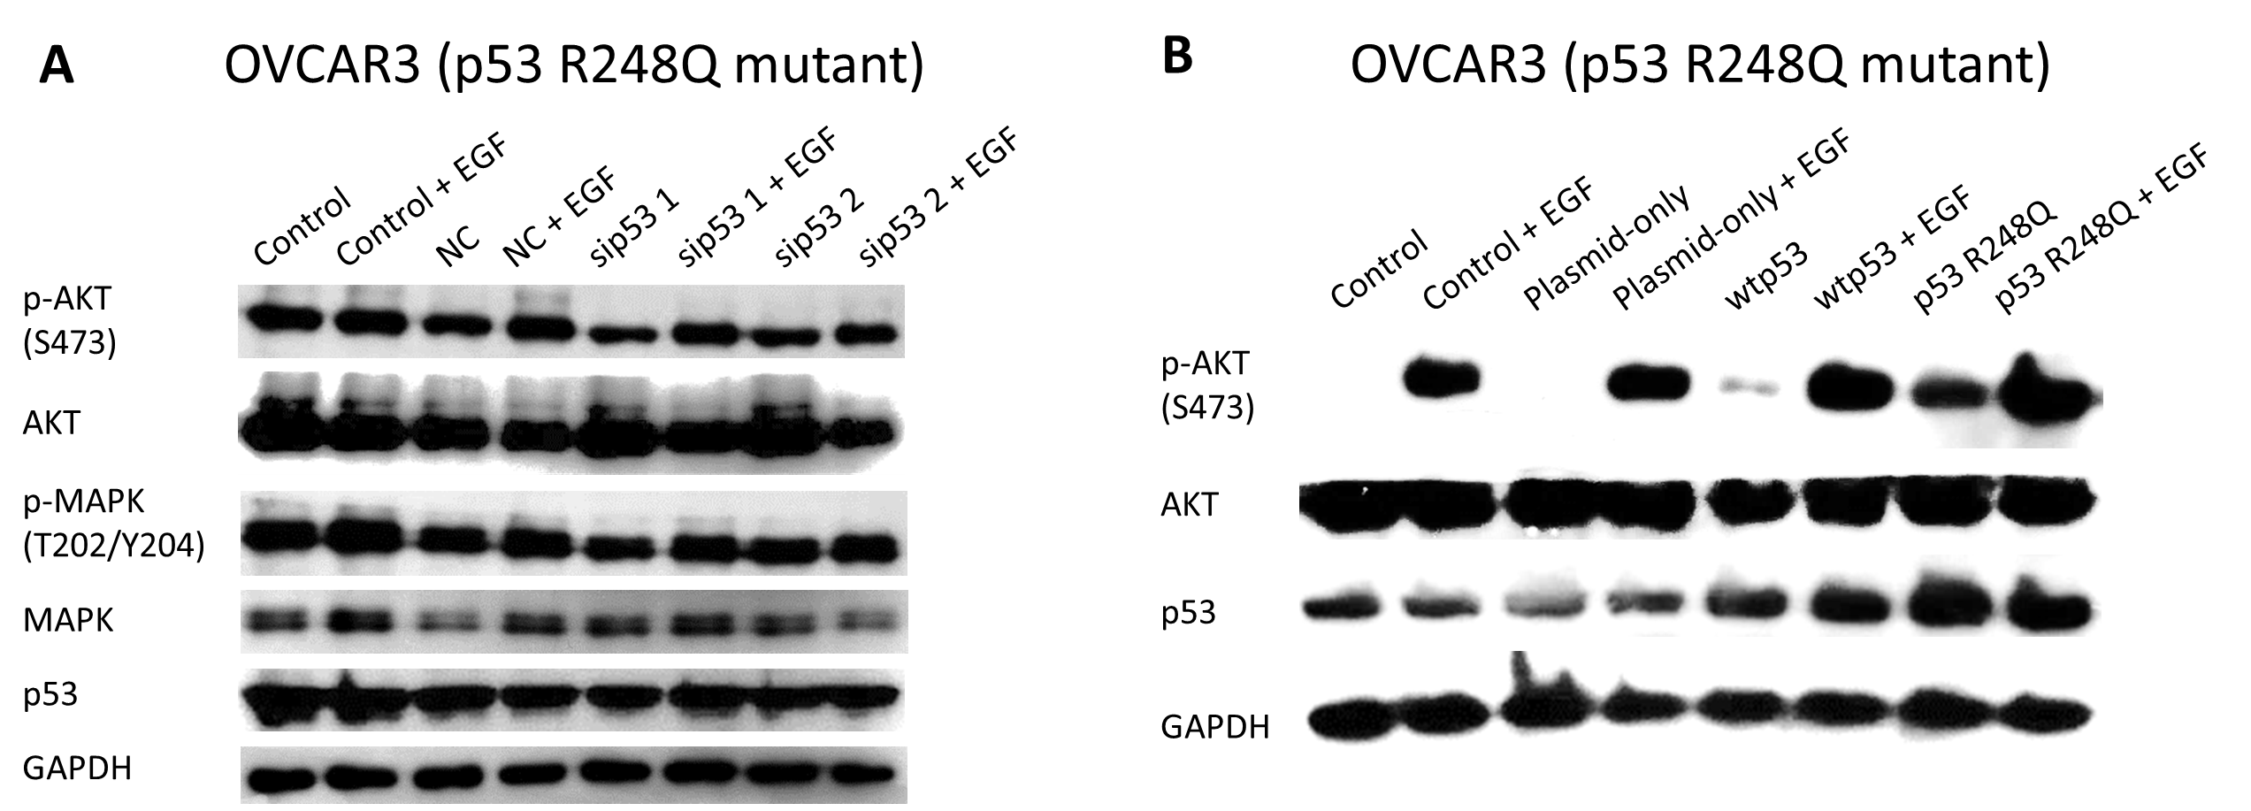

Supplementary Figure 1. p53^{R248Q} resulted in amplification of p-AKT.
(A) The levels of p-AKT and p-MAPK were reduced after transfection with p53 siRNA in OVCAR3 cells. It should be noted that serum-starved OVCAR3 cells were transiently transfected with p53 siRNA (25 nM) or negative control siRNA (25 nM) for 24 hours and then stimulated with EGF for 15 minutes.
(B) The levels of p-AKT were significantly increased after p53^{R248Q} overexpression in OVCAR3 cells. It should be noted that OVCAR3 cells were transiently transfected with either empty plasmid (1 μg/mL), wtp53 (1 μg/mL), or p53^{R248Q} (1 μg/mL) for 24 hours and then stimulated with EGF for 15 minutes.
Phosphorylation of AKT (Ser473) and MAPK 1/2 (Thr202/Tyr204) was determined by immunoblot analysis using corresponding antibodies. GAPDH expression was measured to serve as a loading control.

Supplementary Figure 2. Time-dependent cytonuclear trafficking patterns of EGFR and MDM2
EGFR and MDM2 moved in a convergent manner from the cytoplasm to the nucleus over time after EGF stimulation.

Supplementary Table 1. IC₅₀ values of OVCAR3 cells with different p53 status to EGFR and/or MDM2 inhibitors
Cell Line | Cell Status | Drug Treatment | IC₅₀ (μM)
OVCAR3 | Pretransfected with empty plasmid for 18 hours | JNJ | 21.83
OVCAR3 | Pretransfected with empty plasmid for 18 hours | Gefitinib | 33.74
OVCAR3 | Pretransfected with empty plasmid for 18 hours | JNJ + Gefitinib | 8.57
OVCAR3 | Pretransfected with p53^{R248Q} for 18 hours | JNJ | 14.35
OVCAR3 | Pretransfected with p53^{R248Q} for 18 hours | Gefitinib | 26.47
OVCAR3 | Pretransfected with p53^{R248Q} for 18 hours | JNJ + Gefitinib | 8.18

Supplementary Table 2. Combination index (CI) values and synergism grading of combined JNJ and gefitinib treatment at different effective doses (ED50, ED75 and ED90)
Cell Line | Cell Status | CI Values and Synergism Grading
Cell Line | Cell Status | ED50 | ED75 | ED90
OVCAR3 | Pretransfected with empty plasmid for 18 hours | 0.65  +++ | 0.51  +++ | 0.47  +++
OVCAR3 | Pretransfected with p53^{R248Q} for 18 hours | 0.87  + | 0.72  ++ | 0.67  +++
CI values of specified effective dose (ED) for OVCAR3 cells with different p53 statuses were summarized. The synergism grading of combined inhibition was based on the grading standard defined by Chou and Talalay [38]. CI values from 0.85 to 0.9, 0.7 to 0.85 and 0.3 to 0.7 indicate slight synergism, moderate synergism and synergism, expressed as "+", "++" and "+++", respectively.

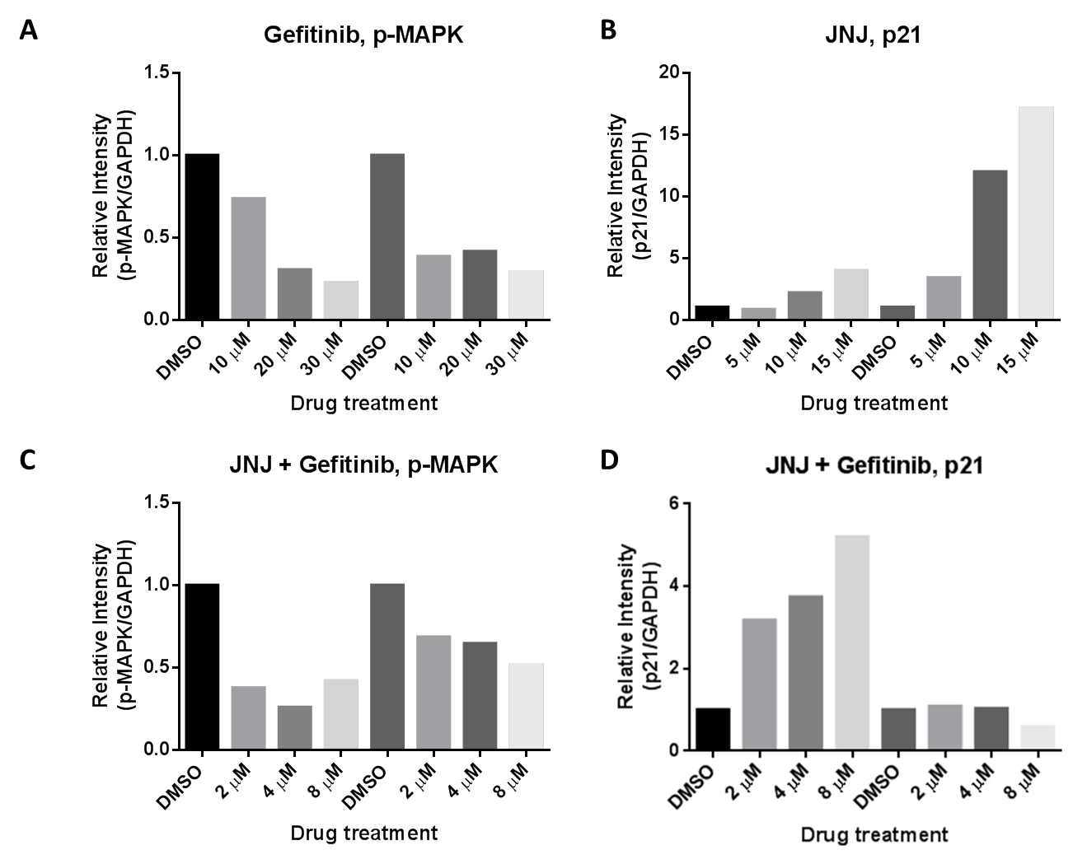

Supplementary Figure 3. Quantification graphs of immunoblots in Figure 5
The band intensity of the immunoblots was quantified using ImageJ software. The relative intensities of p-MAPK or p21 to GAPDH expression were normalized with the DMSO control group.

